**Sales Data Analysis Forecasting**

**Cocoa and Plantain Farming: Project Report**

**Project Title:** Sales Data Analysis Forecasting— Financial Performance and Forecasting

**Objective:** To analyze historical financial and operational performance of cocoa and plantain farming, and forecast future revenue, expenses, and profit to inform strategic decisions.

**Tools**: I used Power query in power bi for data cleaning and Power bi for Data Analysis and visualization. I also used Prophet; a forecasting model to predict financial performance for the next 5 years.

### **Dashboard 1: Performance Analysis**

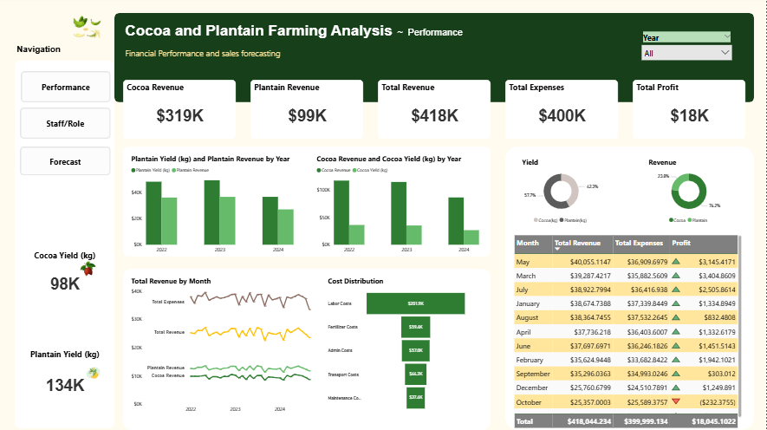

**Key Insights:**

Total revenue from 2022–2024 = **$418K**, with cocoa contributing **$319K** and plantain **$99K** (Cocoa = 76% of income, Plantain = 24%).

**Total Expenses** = $400K, leaving a slim **profit of $18K**.

**October** shows a net loss; possibly seasonal or operational inefficiency. .

**Cocoa** generates more value per **kg** than plantain despite slightly lower yield.

**Labor ($123K)** and **Admin ($83K)** are the largest cost drivers.

**Recommendations:**

Expand cocoa operations and improve plantain efficiency.

Reduce labor and admin costs via automation or workforce restructuring.

Investigate month-on-month loss patterns (e.g., October) for actionable insights.

### **Dashboard 2: Forecast Analysis**

**Key Insights:**

**Average Forecast Revenue ($422)** is slightly higher than **Average Actual Revenue ($418)**, showing **1.04% revenue growth**, indicating modest sales or yield improvement.

**Forecast Profit Margin (5.43%)** is higher than **Actual Profit Margin (4.32%)**, reflecting better anticipated cost control.

**Forecast Profit ($1.37K)** remains relatively low compared to **Forecast Revenue ($25.17K)**, signaling tight profit margins.

**Average Forecast Expense ($384)** is slightly lower than **Average Actual Expense ($400)**, indicating better cost control.

The Average Value for Actual (11.07% increase) and Forecast (3.61% increase) both trended up between January 2022 and December 2028.﻿

Across all 12 Month, Average Actual Revenue ranged from $409 to $431.﻿

Revenue and expenses show steady trends through 2024–2028, suggesting a stable business outlook.

**Grants significantly boosted revenue** in 2022–2024, e.g. $10.6M in 2023 and 2024. - Top sources: European Commission ($4.1M), Private Donors A ($3.6M), Local Government, UNICEF.

**Recommendations:**

Optimize operations further to improve margins.

Reduce reliance on grant funding — grants inflate revenue temporarily but aren’t sustainable. Explore more sustainable income streams.

Investigate scalable revenue strategies (e.g., product diversification, yield improvements).

### **Dashboard 3: Staff and Role Analysis**

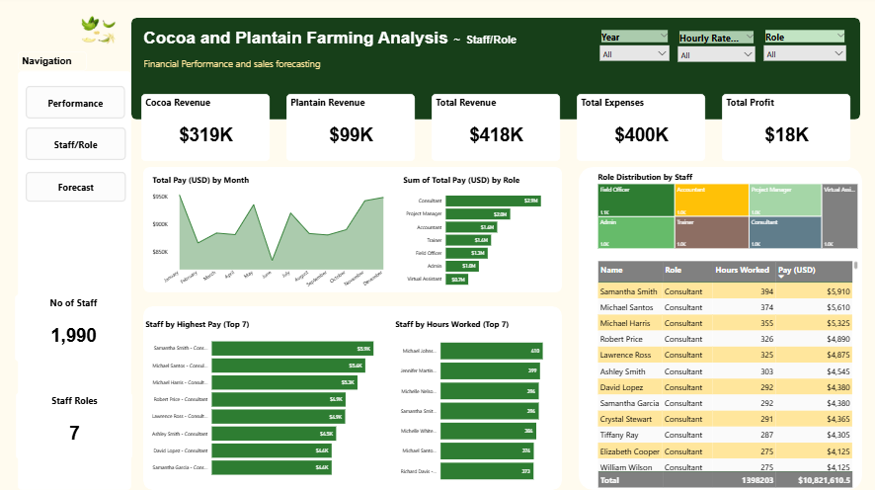

**Key Insights:**

Total Staff: **1,990** across **7 Roles**.

**Consultants dominate pay** but **work less** except Samantha Smith who logged 394hrs **(Top 4)** and earned most **($5.9K).**

**Consultant & Project Manager** roles cost over $2M collectively.

**Field Officers and Accountants** are the most populated roles.

**Recommendations:**

Reassess staff contributions vs cost — are high earners driving enough value?

Align expensive roles with revenue-generating periods.

Consider upskilling or tech investments to reduce dependency on top-cost roles.

**Summary of Findings**

| Area | Insight | Recommendation |
| --- | --- | --- |
| Forecast | Revenue and margins improving slightly | Sustain performance, cut costs |
| Grants | Large revenue booster (2022–2024) | Develop sustainable alternatives |
| Profitability | Still low (<6%) | Focus on cost efficiency |
| Yield | Cocoa > Plantain in value | Expand cocoa initiatives |
| Staff | High-cost roles dominate | Optimize staff ROI |

**Prepared by:** Emediong Bassey Ekanem

**Tool Used:** Power BI + Prophet (Forecasting Model)

**Date:** July 2025